Equality information
Breakdown of protected characteristics:
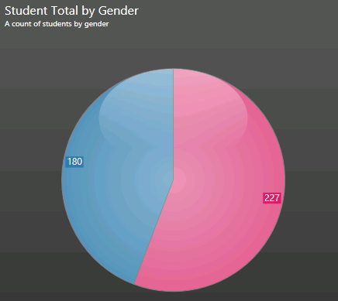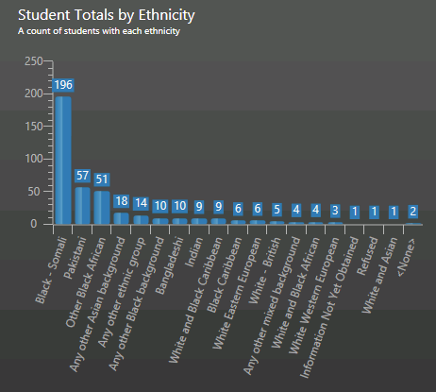
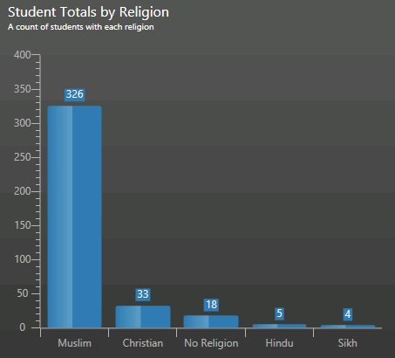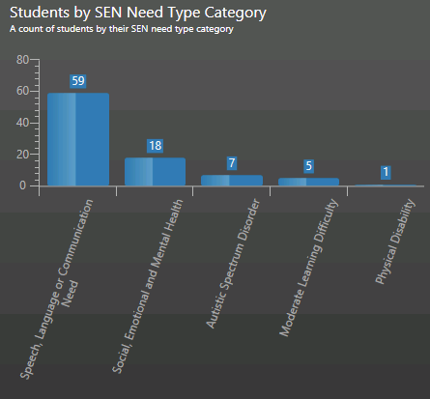
SEN: 21% of the children have SEN
No Information was available on the following protected characteristics:
- Gender Reassignment: Easton CE Academy did not have any information on whether any of the children on roll had reassigned their gender.
- Sexual Identity: Easton CE Academy did not have information on whether any of the pupils on roll identified as Lesbian, Gay, Bi-sexual or Transgender (LGBT) as the question has not been asked as part of routine data collection.

